

OOP
( Course Code: CSC241 )

Name : Syeda Aima Abbas
Roll No # FA24-BSE-010
Instructor Name : Sir Muhsin

Lab # 3(Encapsulation)

Lab Task – 1
Create an Encapsulated class Marks with three data members to store three marks. Create set and get methods for all data members. Test the class in runner

public class Marks {
private int marks1;
private int marks2;
private int marks3;

public Marks(int marks1, int marks2, int marks3) {
setMarks1(marks1);
setMarks2(marks2);
setMarks3(marks3);
}

public void setMarks1(int marks) {
if (marks < 0 || marks > 100) {
System.out.println("Please enter valid marking");
} else {
marks1 = marks;
}
}
public void setMarks2(int marks) {
if (marks < 0 || marks > 100) {
System.out.println("Please enter valid marking");
} else {
marks2 = marks;
}
}
public void setMarks3(int marks) {
if (marks < 0 || marks > 100) {
System.out.println("Please enter valid marking");
} else {
marks3 = marks;
}
}
public int getMark1(){
return marks1;
}
public int getMark2(){
return marks2;
}
public int getMark3(){
return marks3;
}

}

//Runner
public class Runner {
public static void main(String[] args) {
Marks m = new Marks(33, 45, -75);
System.out.println(m.getMark1());
System.out.println(m.getMark2());
System.out.println(m.getMark3());
}
}

Output:
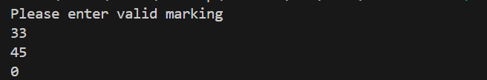
Lab Task – 2
Create an Encapsulated class Account class with balance as data member. Create two constructors and methods to withdraw and deposit balance. In the runner create two accounts. The second account should be created with the same balance as first account. (Hint: use get function)
public class Accounts {
private double balance ;
public Accounts (){
balance=20000;
}
public Accounts (double bal){
setBalance(bal);
}
public void setBalance (double bal){
if (bal>0){
balance=bal;
}
}
public void deposit(double amount){
if (amount > 0){
balance=balance+amount;
}else{
System.out.println("Please enter valid amount");
}
}
public double getbalance(){
return balance;
}
public void widrawAmount (double amount){
if (amount > balance ){
System.out.println("You Do not Have sufficient amount");
}else{
balance=balance-amount;
System.out.println("Amount"+ amount +" has been widrawed And your remaining Balance is" + balance);
}
}
}

//Runner Class
public class Runner2 {
public static void main(String[] args) {
Accounts a = new Accounts();
System.out.println( a.getbalance());
a.deposit(1000);
System.out.println( a.getbalance());
a.widrawAmount(3000);
System.out.println( a.getbalance());

Accounts am = new Accounts(30000);
System.out.println( am.getbalance());
am.deposit(1000);
System.out.println( am.getbalance());
am.widrawAmount(3000);
System.out.println( am.getbalance());
}
}

Output:
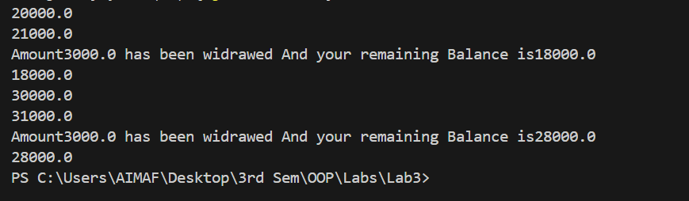
Lab Task – 3
Lab Task 3 Create an Encapsulated class Student with following characteristics: Data Members: String Name Int [] Result_array[5] // Result array contains the marks for 5 subjects Methods: Student ( String, int[]) Average () // argument Constructor // it calculates and returns the average based on the marks in the array. Runner: Create two objects of type Student and call the Average method. 24 Compare the Average of both Students and display which student has higher average. Create a third student with name as object 1 and result array as object 2
public class Students {

private String name;
private int[] resultArray;

public Students(String name, int[] resultArray) {
this.name = name;
this.resultArray = new int[resultArray.length];
for (int i = 0; i < resultArray.length; i++) {
this.resultArray[i] = resultArray[i];
}
}

public double average() {
int sum = 0;
for (int mark : resultArray) {
sum += mark;
}
return (double) sum / resultArray.length;
}

public String getName() {
return name;
}
}

// runner class
public class Runner3 {
public static void main(String[] args) {

int[] marks1 = {80, 75, 90, 85, 95};
int[] marks2 = {60, 70, 65, 75, 80};

Students s1 = new Students("Ali", marks1);
Students s2 = new Students("Sara", marks2);

double avg1 = s1.average();
double avg2 = s2.average();

System.out.println(s1.getName() + "'s average: " + avg1);
System.out.println(s2.getName() + "'s average: " + avg2);

if (avg1 > avg2) {
System.out.println(s1.getName() + " has higher average.");
} else if (avg2 > avg1) {
System.out.println(s2.getName() + " has higher average.");
} else {
System.out.println("Both have equal average.");
}

Students s3 = new Students(s1.getName(), marks2);
System.out.println("Third student " + s3.getName() +
" has average: " + s3.average());
}

}

Output:
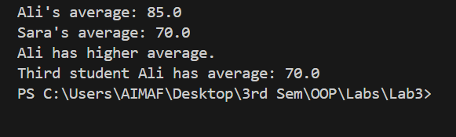

Lab Task – 4
Suppose you operate several hot dog stands distributed throughout town. Define an Encapsulated class named HotDogStand that has an instance variable for the hot dog stand’s ID number and an instance variable for how many hot dogs the stand has sold that day. Create a constructor that allows a user of the class to initialize both values. Also create a method named justSold that increments by one the number of hot dogs the stand has sold. The idea is that this method will be invoked each time the stand sells a hot dog so that you can track the total number of hot dogs sold by the stand. Write a main method to test your class with at least three hot dog stands that each sell a variety of hot dogs. Use get function to display the hot dogs sold for each object.
public class HotDogStand {
private int id;
private int hotDogsSold;

public HotDogStand(int id, int hotDogsSold) {
this.id = id;
this.hotDogsSold = hotDogsSold;
}

public void justSold() {
hotDogsSold++;
}

public int getHotDogsSold() {
return hotDogsSold;
}

public int getId() {
return id;
}
}

//Runner Class
public class Runner4 {
public static void main(String[] args) {

HotDogStand stand1 = new HotDogStand(101, 5);
HotDogStand stand2 = new HotDogStand(102, 3);
HotDogStand stand3 = new HotDogStand(103, 7);

stand1.justSold();
stand1.justSold();

stand2.justSold();

stand3.justSold();
stand3.justSold();
stand3.justSold();

System.out.println("Stand " + stand1.getId() +
" sold " + stand1.getHotDogsSold() + " hot dogs.");
System.out.println("Stand " + stand2.getId() +
" sold " + stand2.getHotDogsSold() + " hot dogs.");
System.out.println("Stand " + stand3.getId() +
" sold " + stand3.getHotDogsSold() + " hot dogs.");
}
}

Output:
